Understanding & Conserving Biodiversity

- How many species have been described by scientists?

- What is the estimate of how many are alive today?

- What constitutes a mass extinction?

- When was the last great mass extinction?

- Which groups are currently threatened with extinction?

- Why should we be concerned with the loss of biodiversity?

- What is the primary cause of today’s loss of biodiversity?

- What are the three types of biodiversity?

- Species Diversity

- Give a brief description of “Pando”??

- Among living organisms where is the greatest metabolic diversity found?

- What are extremophiles?
- Most new species identified are from which group?

- Since 2000 how many new species of primates have been described?

B. Genetic Diversity

- What are genes responsible for?

- Why is genetic diversity considered a separate category?

- What does genetic variation allow species to do?

- What does genetic engineering allow scientist to do?

- Give some (more than 2) examples of what genetic engineering has allowed scientists to do.

- Ecosystem Diversity

- What does ecosystem diversity include?

- What biological process are preserved when ecosystems are intact?

- What does a conservation focus on preserving ecosystems save?

Why Conserve Biodiversity?

- What are the 3 reasons humans should be concerned about saving biodiversity?

- What are biological resources?

- How many food crops do humans heavily rely on?

- What is biomimicry and how could it be a benefit to humans?

- What are ecosystem services?

- What is the global economic value of pollination services performed by insects?

- What is ecotourism?

- When was the first national park set aside? What group was responsible for this?

30. In your own words, why do YOU think biodiversity in our natural environment should be preserved?

Article #1

Understanding & Conserving Biodiversity
By: Carol Ann Kearns (Department of Ecology and Evolutionary Biology, University of Colorado at Boulder) © 2010 Nature Education

Reading Focus:
- Passages addressing different types of biodiversity & their importance
- Passages emphasizing how humans impact biodiversity & why we should conserve it

Life has existed on Earth for over 3.5 billion years. Over 95% of the species that ever existed have gone extinct. So why should we be concerned about current extinction rates and conserving biodiversity?

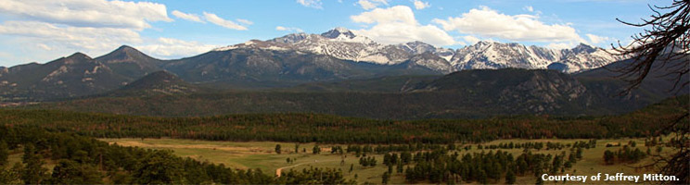

Currently the planet is inhabited by several million species in about 100 different phyla (Dirzo & Raven 2003). About 1.8 million have been described by scientists (Hilton-Taylor et al. 2008), but conservative estimates suggest that there are 5–15 million species alive today (May, 2000), since many groups of organisms remain poorly studied. Over 15,000 new species are described each year (Dirzo & Raven 2003), and new species are evolving during our lifetimes. However, modern extinction rates are high, at 100 to 1000 times greater than background extinction rates calculated over the eras (Hambler 2004). Although new species appear, existing species go extinct at a rate 1000 times that of species formation (Wilson 2003). Many biologists agree that we are in the midst of a mass extinction, a time when 75% or more of species are lost over a short geological time scale (Raup 1994). The last great mass extinction was 65 million years ago, at the end of the Cretaceous, when the dinosaurs went extinct. The International Union for the Conservation of Nature estimates that 22% of known mammals, 32% of amphibians, 14% of birds, and 32% of gymnosperms (all well-studied groups) are threatened with extinction (Hilton-Taylor et al. 2008). Species that were abundant within the last 200 years have gone extinct. For example, passenger pigeons, which numbered three to five billion in the mid 1800s (Ellsworth & McComb 2003), are now extinct.
Why should we be concerned about this loss of biodiversity? The answer lies in the fact that, for the first time in Earth’s history, a single species, Homo sapiens, could cause a mass extinction, precipitating its own demise. The primary cause of today’s loss of biodiversity is habitat alteration caused by human activities.
Let’s think about the meaning of biodiversity. Most people understand that biodiversity includes the great heterogeneous assemblage of living organisms. This aspect of biodiversity is also known as "species diversity." Biodiversity includes two other components as well- genetic diversity and ecosystem diversity.

The Meaning of Biodiversity
- Species diversity
Figure 2: Over 15,000 new species are described each year.
This newly described gecko from Ecuador fits on the head of a pencil (Courtesy of Paul S. Hamilton/RAEI.org).

The 1.8 million species described by science are incredibly diverse. They range from tiny, single-celled microbes like Nanoarchaeum equitans, 400 nm in diameter living as parasites on other microbes in thermal vents at temperatures of 70–98°C (Huber et al. 2002), to giant organisms like Sequoias, blue whales, the "humungous fungus," and "Pando" (Figure 1). "Pando" is the name given to a clonal stand of aspen trees, all genetically identical and attached to each other by the roots (Grant et al. 1992). The stand covers 106 acres and weighs 13 million pounds. The "humungous fungus," a giant individual of the species Armillaria oysterae is found in the state of Oregon, and covers 1,500 acres (USDA Forest Service 2003).
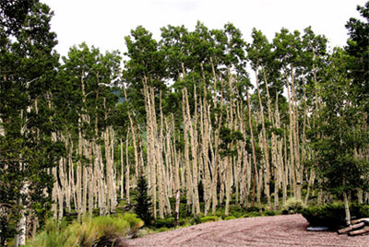
Figure 1: "Pando" is a giant aspen clone in the Fish Lake National Forest, Utah.
"Pando" is one of the world’s largest organisms, weighing 13 million pounds and covering 106 acres. (Courtesy of Jeffry Mitton)
While people are generally most familiar with multicellular organisms such as plants and animals, these organisms form only small branches on the tree of life. The greatest metabolic diversity is found among the prokaryotic organisms of the Eubacteria and Archaea. Although some of these microbes use oxygen for respiration, or photosynthesize like plants, others have the extraordinary ability to derive energy from inorganic chemicals such as hydrogen sulfide or ammonia, and they use carbon dioxide as their only source of carbon for producing organic molecules. Organisms that we consider extremophiles can survive in saturated salt concentrations (36% compared to approximately 3% for seawater), or in superheated water in deep-sea vents and geysers.
Because people have ventured to all parts of the globe, one might expect that the new species being discovered each year would be microscopic organisms that can only be distinguished at the metabolic level. While it is true that most new species identified are insects, microbes and fungi, we are still discovering new vertebrates (Figure 2), even sizable new vertebrates such as a new species of baleen whale and a clouded leopard. Since 2000, 53 new species of primates have been described (IUCN 2008) including a new species of Brazilian monkey, Mura’s saddleback tamarin.
- Genetic Diversity
Genes are responsible for the traits exhibited by organisms and, as populations of species decrease in size or go extinct, unique genetic variants are lost. Since genes reside within species, why should we consider genetic diversity as a separate category? Because they hold "genetic potential." For example, many of the crops that we grow for food are grown in monocultures of genetically homogeneous individuals. Because all individuals are the same, a disease, insect pest, or environmental change that can kill one individual can extirpate an entire crop. Most of our high-yield varieties show significant reductions in yield within about 5 years, as pests overcome the crops’ natural defenses. Plant breeders look to wild plant relatives and to locally grown landraces to find new genetic varieties. They can then introduce these genes into crops to renew their vigor. However, according to the UN Food and Agriculture Organization, 96% of the 7,098 US apple varieties cultivated prior to 1904, 95% of the US cabbage varieties, and 81% of tomato varieties, are extinct, and the genes that made these varieties unique are gone.
Genetic variation allows species to evolve in response to diseases, predators, parasites, pollution, and climate change. The Red Queen Hypothesis, named for Lewis Carroll’s character who runs continually in order to stay in the same place, states that organisms must continually evolve, or succumb to their predators and parasites that will continue to evolve.
In addition to traditional breeding, advances in genetic engineering have allowed scientists to introduce beneficial genes from one species to another. For example, diabetics used to depend on insulin from human cadavers, or from cows or pigs. Human insulin was expensive, and non-human insulin could cause allergic reactions. Now we can isolate the gene that codes for human insulin, insert it into bacterial cells, and let the bacteria produce large quantities of human insulin. Other notable feats in genetic engineering include the introduction of genes that enhance the nutritive value of food, create crop resistance to insect pests, induce sheep to produce a protein for treating cystic fibrosis disease, and alter bacteria so that they can clean up toxic mine wastes through their metabolic activities. Many other genetic manipulations are currently in development.
- Ecosystem Diversity
Ecosystems include all the species, plus all the abiotic factors characteristic of a region. For example, a desert ecosystem has soil, temperature, rainfall patterns, and solar radiation that affect not only what species occur there, but the morphology, behavior, and the interactions among those species (Figure 3). When ecosystems are intact, biological processes are preserved. These processes include nutrient and water cycling, harvesting light through photosynthesis, energy flow through the food web, and patterns of plant succession over time. A conservation focus on preserving ecosystems not only saves large numbers of species (including non-charismatic species that do not receive public support) but also preserves the support systems that maintain life
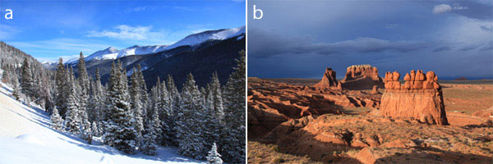
Figure 3: Physical features of an ecosystem affect what species survive there.
(A) In sharp contrast to desert habitats, this lush spruce-fir forest near Berthoud Pass, in Colorado, receives an average of 38 inches of precipitation per year, largely in the form of snow. (B) The sandstone pinnacles of Goblin Valley, Utah occur in high desert in the San Rafael Swell. The area receives less than 8 inches of annual precipitation. (Courtesy of Jeffry Mitton)

Why Conserve Biodiversity?
From a selfish point of view, humans should be concerned about saving biodiversity because of the benefits it provides us–biological resources and ecosystem services. However, nature provides social and spiritual benefits as well.
- Biological Resources

Biological resources are those products that we harvest from nature. These resources fall into several categories: food, medicine, fibers, wood products, and more. For example, over 7,000 species of plants are used for food, although we rely heavily on only 12 major food crops. Most of the human population depends on plants for medicines. In the developed world, many of our medicines are chemicals produced by pharmaceutical companies, but the original formulas were often derived from plants. For example, opiate pain relievers are derived from poppies, aspirin is derived from willows, quinine for treating malaria comes from the Chinchona tree. The rosy periwinkle (Vinca rosea) and Pacific yew (Taxa brevifolia) both provide substances used in chemotherapy to inhibit the cell division of cancerous cells. Fibers for clothing, ropes, sacking, webbing, netting, and other materials are provided by a large number of plants, including cotton plants, flax plants (linen), hemp (cordage and sail canvas), Agave plants (sisal), Corchorus plants (jute), bamboo and palms. Trees provide the wood products used in making homes, furniture, and paper products.
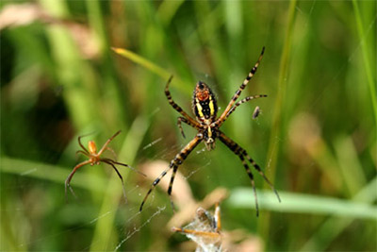
Figure 4: The tensile strength of spider silk provided inspiration for engineering a similar synthetic fabric. This large female Argiope trifasciata spider has a male suitor, and dinner waiting in her silken web. (Courtesy of Jeffry Mitton)

In addition, living organisms provide inspiration for engineers seeking better and more efficient products. The field known as biomimicry is the study of natural products that provide solutions to human needs. For example, shark skin provided the model for hydrodynamic swimming suits. The glue used by Sandcastle worms (Phragmatopoma californica) to cement together their sand particle shells was the inspiration for a glue that mends fractured bones in the aqueous internal environment of the body. Finally, scientists are using the chemical nature of spider’s silk to design strong, lightweight fibers (Figure 4).
- Ecosystem Services
Ecosystem services are processes provided by nature that support human life. These services include the decomposition of waste, pollination, water purification, moderation of floods, and renewal of soil fertility. Ecosystem processes are often overlooked, and are not generally valued as part of the economy until they cease to function. When economic value is assigned to these services, it is often startlingly high. For example, insect pollinators help produce many commercially important fruits such as almonds, melons, blueberries, and apples. The global economic value of pollination services performed by insects has been valued at $217 billion per year (Gallai et al. 2009).
How does a process like water purification work? Rain water is filtered by soil and by microbes that can break down nutrients and contaminants, and reduce metal ions, slowing their spread into the environment. Wetland and riparian plants absorb nitrogen, and trap sediments that decrease water quality.
Human construction and development disrupt natural environments, but most habitats have an extraordinary ability to recover when given the chance. This is because dormant seeds in the soil can germinate, stabilize the soil, and initiate successional events that restore vegetation which provides food and structure for other colonizing organisms. Native plants like fireweed can help revegetate an area after fire.
- Social and Spiritual Benefits
Throughout most of human history, conservation has involved protecting nature for the spiritual gifts it provides, and protecting sacred places in the local landscape. Stories of indigenous people incorporate detailed knowledge of the animals and plants that make up their world. The heterogeneity of the world’s mythology, folk art, and folk dances show the effects of biodiversity on cultural development, and contribute to the richness of global arts and literature.
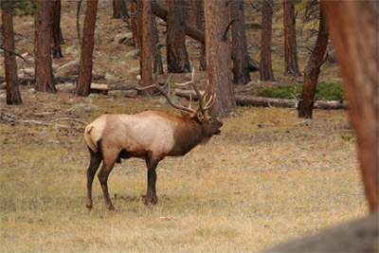
Figure 6: People flock from around the world to see the bull elk bugling and displaying during mating season at Rocky Mountain National Park.
Courtesy of Jeffry Mitton.

Different cultures developed in different landscapes that influenced activities, occupations, diet, language, and architecture. Cultures adapted to local environmental challenges by growing local domestic crops, developing irrigation and terracing systems, hunting, fishing, and gathering. Biodiversity provides a sense of place. Countries and states have flagship animals and plants that are a source of pride and highlight the uniqueness of each habitat (Figure 6). Travel, which provides great pleasure to many people, is motivated by the desire to see this combination of cultural, landscape and biological diversity.
Ecotourism is travel with the desire to view, sustain, and support natural ecosystems and local cultures. Support from ecotourism can reduce habitat destruction, preserve species that suffer from poaching and illegal trade in the pet market, plus provide jobs for the local economy. For example, the Wasini Island Project in Kenya has been a major ecotourism success story. Coral reefs and mangrove forests were suffering degradation from development, agriculture, and from exploitation of reef species. Support from the Biodiversity Conservation Programme made it possible for the local community to build boardwalks and other features that facilitate viewing wildlife. Local people were trained as guides and in administration, and they now run a profitable ecotourism operation. Money from tourism helps the local economy, provides incentive to maintain the habitat, provides funds for the local health clinic, and scholarships for local students (Peopleandplanet.net 2009).
In recognition of the aesthetic value of nature, in 1892 the US Congress set aside the first national park "for the benefit and enjoyment of the people" (NPS 2010). Frederick Law Olmstead, who in the 1800s designed and managed park systems and urban parks such as Central Park in New York City, believed in the rejuvenating powers of nature. He felt that contemplating nature’s grandeur allowed man to put his life into perspective. In modern times, with increasing urbanization, people seek out local parks, open space and trails, and travel to national parks and wild places where they can enjoy nature. Birding, hiking, fishing, hunting, gardening, and other forms of recreation in nature are popular activities, and are economically important.
While modern arguments often focus on the anthropocentric value of biodiversity, nature writers such as Emerson, Thoreau, Leopold, Muir and many others emphasized the intrinsic values of biodiversity. As Henry David Thoreau said, "This curious world which we inhabit is more wonderful than it is convenient; more beautiful than it is useful; it is more to be admired and enjoyed than it is to be used" (1837).

