Name: _____________________________________ Date: _______________ Group:_______ Period:_______
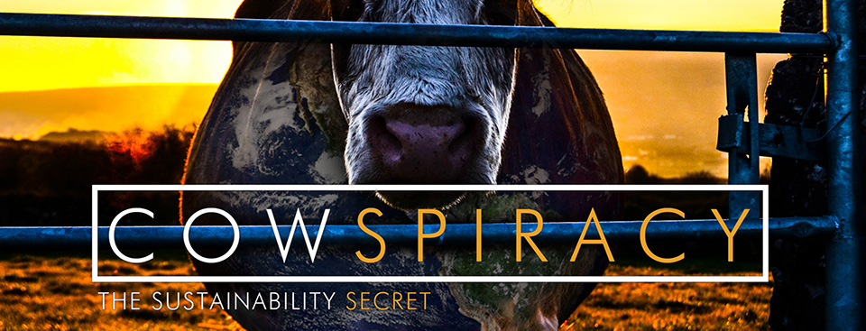

Pre-viewing Questions:
- Based solely on the title above (TRY not to look below please ), what do you think the main idea (claim) of this movie will be?

- The following is the very opening quote shown in the movie. How does this change your answer to question #1?
“In the end, we will remember not the words of our enemies, but the silence of our friends.” - Martin Luther King Jr

While Viewing Questions:
INTRODUCTION
- The United Nations post that sparked Kips interest to create this film stated that _________ _________ produces more greenhouse emissions than the entire transportation sector (cars, truck, boats, planes combined.)

- Methane gas from livestock is ______ times more destructive than carbon dioxide from vehicles.

- Livestock is the leading cause of ______________________ and environmental degradation today.

- In his research, Kip learns that hydraulic fracking (for natural gas extraction) uses _____ __________ gallons of water each year in the United States AND that animal agriculture uses _____ _____________.

- Methane emissions from the fracking industry and the animal agriculture industry are nearly____________.

- According to Heather Cooley of the Pacific Institute, the average Californian uses about _________ gallons of water each day and about half of that is related to the consumption of _________ and _________ products. Why is it so much?

- One quarter pound hamburger requires over _________ gallons of water to produce. (That is the equivalent of taking short showers for two ______________.

- According to Kip’s research, in the US about ______% of our fresh water is used for domestic use and _____% is used for animal agriculture.

- It takes ____________ gallons of H2O = 1 pound of beef

- What recommendations does Mr. Manucher Alemi from the California Department of Water Resources suggest consumer use for conserving water?

- What concerns did the CA Dept of Water Resources officials offer regarding animal agriculture and water use when Kip suggested a campaign to reduce meat consumption? Do you agree or disagree with their stand point? Why?

(approximately min 11) Pause Movie for reflection time

INVESTIGATING FUTHER
- Transportation and Energy sectors are given a lot of attention by environmental groups (understandably) because the terrible impact that carbon dioxide is having on our climate. Consider this: animal agriculture produces 65% of the world’s ____________ ______________ a gas with the global warming potential _________ times greater than carbon dioxide per pound.

- Emissions from agriculture are predicted to increase _______% by 2050 due to:

- Raising animals for food is responsible for ________% of the world’s water consumption, occupies up to _______% of the Earth’s land, is responsible for up to _______% of Brazilian amazon destruction and is the leading cause of ocean __________ __________, habitat destruction and species __________________.
- What does **Michael Pollan** (& the other environmentalists shown) suggest may be the reason why animal agriculture is not being addressed by large environmental groups?

- Gross fact: 116 thousand pounds of farm animal excrement is produced every ____________ in the US alone.

ANIMAL AGRICULUTRE AND THE OCEAN
- EVERYTHINIG IS CONNECTED: Livestock operations on land (& its agricultural run-off) have created more than _________ nitrogen flooded dead zones around the world and in our oceans.

- “Our oceans are in near collapse.” The UN reported that ________ of the world’s fisheries are over-exploited, fully exploited or significantly depleted due to:

- Last year over 28 _______________ animals were pulled out of the ocean last year.

- Primary current fishing techniques require the use of massive fishing nets. For every single pound of fish caught, there is up to _______ pounds of untargeted species trapped such as______________________known as by-kill.

- Describe what Dr. Richard Oppenlander means by the term “serial depletion”:

- It is Sea Shepard’s position that there is no such thing as sustainable fishing. Based on the information provided do you agree or disagree with this position? Why or why not?

(approximately min 30) Pause Movie for reflection
ANIMAL AGRICULUTRE AND THE RAINFOREST – THE PLANET’S LUNGS
- An acre of rainforest is cleared every ______________. The leading cause is to ______________ animals and ______________their food crops.

- It is estimated that every day close to ________ plant, animal and insect species are lost due to deforestation.

- Palm Oil plantations are the number one cause of deforestation of rainforests in Indonesia. It is estimated that Palm Oil is responsible for _____ million acres being cleared. Though, animal agriculture is responsible for ________ million acres of rainforest deforestation to date.

- Is cattle listed as one the four main key issues on the Rainforest Action Network website?

- According to the representative of AMAZON watch what is the primary driver of rainforest destruction?

- Does her position change as she is asked a second time? If so, how?

- Dorothy Stang was a US born nun living in the heart of the amazon rainforest. Her life’s work was to protect the rainforest. What happened to her in 2005?

- Over ___________ activists have been killed in the last 20 years in Brazil.

OTHER ENVIRONMENTAL GROUPS
- Will Anderson, Former board of directors Greenpeace USA, states that animal agriculture is also not part of the Greenpeace initiatives. He goes on to stat the he believes that then environmental community is ______________ us and failing _________________.

- Ann Notthoff, CA Advocacy Director for the Natural Resources Defense Council, says not to quote her on what?

- Methane production from cows and other livestock’s flatulence contributes __________ billion gallons of Methane per day.

- Livestock produces ________ times more waste than the human population.

SUSTAINABLE FARM VISIT
- Do you agree with the farmer’s statement that Brazilians shouldn’t be eating beef? Why or why not?

- DO THE MATH: The “sustainable grass-fed beef farmers” state that their land of 45,000 acres produces 80,000 lbs of meat. The average American eats _________ lbs of meat/year. Using their model that would mean only ________ people could be fed on their land. That equates to ________ acres per person. So, if there are 314 million American then we would need _______ billion acres of grazing land. Unfortunately, there are only _______ billion acres of land in the lower 48 states.

- Is the United States suited to meet our own needs for sustainable, grass fed beef?

MMMMMM…..MILK & DAIRY
- Does Marcus Benedetti, President/CEO of the Clover-Stornetta Dairy, believe that their product is sustainable for the world’s population?

- Typically a cow eats about ___________ pounds of feed a day and drink about ___________ gallons of water.

- All dairy cows eventually go where?

- One gallon of milk takes upwards of ___________ gallons of water to produce it.

DESERTIFICATION & OTHER COMPETING ANIMALS
- Almost ________ of the planet’s land is becoming desert, the vast majority due to livestock _______________.

- Warning…..sadness coming Why were the elephants being killed?

- Why are wild horses and burros being removed from Federal Land?

- What has happened to the wolves and other predators in competition with livestock for range lands?

$$$$, LOBBYISTS, LAWSUITS & TERRORISTS?!?
- David Simon, Author of “Meatonomics” claims that the externalities (hidden costs on society) of animal agriculture is approximately $_________________. If meat and dairy industries were to include those into the cost of their products in their retail price, the prices would (circle one) increase/decrease dramatically.

- According to the representative of AAA Emily Meredith, advancements in agriculture such as moving animals inside and CAFOs have what impact on animals? Do you agree/disagree? Why?

- Former Cattle Rancher Howard Lyman was sued (and later extricated) by the cattle industry after appearing on the Oprah Winfrey show. Summarize what the Food Disparagement Law is:

- Currently, if Mr. Lyman was to go to the Oprah show today & saw EXACTLY what he said today, would he still be found not guilty? Why/why not?

- Author Will Potter states that according to the FBI, the number one domestic terrorism threat is what? Why (in his opinion)?

HUMAN POPULATION & POVERTY vs. ANIMAL AGRICULTURE
- In 1812, there were _____ billion people on the planet.
In 1912, there were _____ billion people on the planet.
In 2001, there were _____ billion people on the planet & the # of farm animals they raised is ______ billion.

- The human population drinks _____ billion gallons of water each day & eats _____ billion pounds of food.
The world’s 1.5 billion cows drink _____ billion gallons of water each day & eat _____ billion pounds of food.

- Roughly 1 billion people world-wide are starving. ________% of starving children lives in countries that what?

- You can produce on average _______ times more protein from plant-based sources than from meat on any given acre of land.

- According to Michael Pollan, today Americans are eating (on average) ______ oz of meat per day. He suggests that in order for us to be sustainable with a growing population that we reduce that to 2 oz per ___________.

BACKYARD FARMING & PLANT BASED FOODS
- Backyard farmer Bill Phillips has ______ ducks. He buys one 75 pound bag of seed and that lasts him about ___________________.

- Warning…..SUPER sadness coming Could you do it? Is it okay for someone else to do it for you? Why or why not?

- Why was the chicken Kip rescued going to be slaughtered?

- What “meat alternatives” does Kip introduce you to?

- Howard Lyman says that “You can’t be an environmentalist and eat animal products. Period.” Elaborate on why you think he makes such bold claim below. Does he have evidence to support this claim?

(approximately 1:15, pause for reflection)

GOING VEGAN
- Vegan Dr. Michael Klaper, MD doesn’t believe that humans should be consuming dairy. Why?

- What alternatives to animal manure are used by EARTHWORKS URBAN FARM for plant agriculture?

- To feed a person on an all plant based vegan diet for one year requires ________ acre of land.
To feed that same person a vegetarian diet (includes eggs & dairy) requires _______ times as much land.
To feed that same person the average human diet (including meat, eggs, dairy) require ______ times as much.
This is because you can produce _____________ lbs of vegetables on 1.5 acres and only ________ lbs of meat.

- The average Californian can reduce their CO2 emissions ________ tons by removing beef from their diet,
_______ tons by going vegetarian, _________ tons by going vegan.

- Kip calculated that switching to a vegan lifestyle allows him to save (PER DAY):
  - _______________ gallons of water
  - _________ lbs. of grain
  - _________ sq. feet of forest
  - _________ lbs. of CO2
  - _________ animal’s life

POST-VIEWING
- Kip says that he made a decision “instead of eating others to eat for others” and embraced the vegan lifestyle. What do you anticipate the biggest challenge is that you would face if you were to do the same? What benefits would a vegan lifestyle provide you?

- Look back at the Martin Luther King quote that was at the start of the movie. Why do you think the producers selected this quote? What does it have to do with the movie’s theme/major claims?

- The final quote: “You can change the world. You MUST change the world.” – Howard Lyman
Do you agree? Disagree? Why or why not?

- What are 3 things that you could change to promote “thrivability.”

- What is the one thing from this movie that stands out the most/that you think will stay with you forever?

