Water WebQuest
Of all the water on Earth, over 97.5% is sea water. Life-supporting to be sure, but unusable in its natural state for humans. Only 2.5% of the available water on Earth is fresh water, for drinking, washing, crops, and industry. Close to 70% of that fresh water is locked up as ice, making it unavailable for conventional use. This means less than 1% of the Earth’s fresh water is available for humans and other living things to use, in the form of soil and atmospheric moisture and surface water. Understanding our personal, national, and global water consumption is an important part of identifying the human ecological impact on Earth.
Water availability varies from country to country, as does the per capita (individual) use of water. In this assignment, we will analyze our domestic and industrial uses, compare that with other nations’ usage, explore solutions for water security, and look at some current cases related to misuse of water resources. But first we need to understand some water vocabulary.
Using the website www.waterfootprint.org, define the following terms:
I. Calculating Water Footprints
A. Glossary
- Blue water

- Blue water footprint

- Green water

- Green water footprint

- Grey water footprint

- Ambient water quality standards

B. Your Water Footprint
- Read the introductory page about why we should care, ways to reduced consumption, and how our food choices influence our water footprint.

- Click on the extended water footprint calculator and answer the questions to the best of your ability. Consider your family usage and incorporate an average if you like, but focus mostly on yourself. If you know a parent’s salary (at the end) you may use it. Otherwise, use the median household income of $50,000 in the U.S.

Your Water Footprint
Components: | In m³/year | Calculate Percentage  (show work) | Percent of Total
Food

Domestic

Industrial

TOTAL |  |  | 100%
To figure out the percentage each part uses, think……part/whole X 100
- In which area(s) of food consumption was your footprint the highest? Comment—were you surprised? How does it make you feel about your food choices? Would you change anything?

- What do you think is your largest source of domestic (home) use? Name three ways you can reduce it.

- Why did the survey ask for your median household income---how does that affect industrial consumption?

- How can we change our consumer habits to reflect more responsible industrial water use?

- Why should we care about water consumption and conservation?

- Click on Product Water Footprint. Go to the Product Gallery and use the rotating tool to compare the water footprint of various products. Make some notes on things that surprise you and things that fall within “normal” limits.
- Produce (apples, bananas, oranges, peaches, lettuce, tomatoes, potatoes)
- Grains (bread, rice, corn)
- Sugar (beet or cane)
- Fuel (maize, soy, sugar beet, sugar cane)
- Meat (beef, pork, chicken)
- Other commodities (chocolate, leather, cotton, alcohol)

- Which products tend to use the most water?

- Which products tend to use the least water?

- What trends do you notice in the type of water used (blue, green, grey)?

- Why is the water footprint for beef so high?

- What environmental effect has cotton harvesting had in Asia?

- What is the most water-efficient type of biodiesel fuel? What is the least?

C. Global Water Footprint
- Click on Why water is a global resource?
  - What are the two largest international flows?

  - What trend(s) do you observe in this map?

  - Is much water going Africa? Why do you think the water balance is so high in the most developed countries?

  - In what forms does this water actually travel?

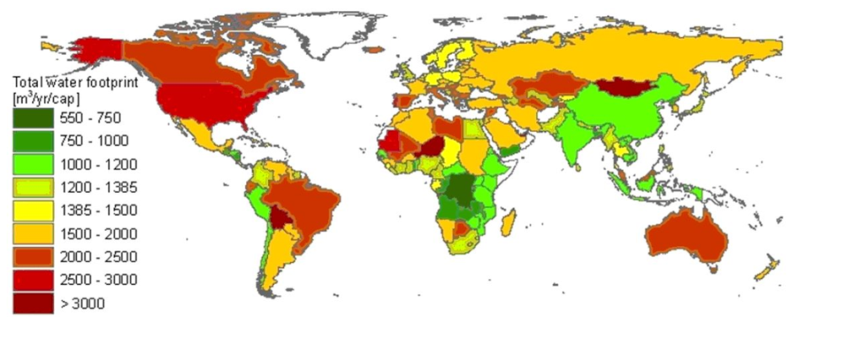
- Here is a graph of annual per capita water footprint.

  - What two factors control the water footprint of a country?

    - How does this idea explain the relatively large water footprint of West Africa?

    - Speculate why Brazil, Australia, and central Asia have such high water footprints.

  - Per capita footprints:
    - Global average—

    - U.S.—

    - China—

III. Water Security
Click on this link for an infographic on global water availability. You will have to increase the zoom to 200% to read it. http://www.waterfootprint.org/downloads/2010-US-Infrastructure.png

The poster helps explain the idea of water security, especially in desert regions where many countries import water. Is there a way for a country to become more self-sufficient? Consider desalination.
http://idadesal.org/desalination-101/desalination-overview/

- Two main methods for removing salt from seawater. Discuss method and energy requirement.

  - Evaporation

  - Reverse osmosis

- Focus for new emerging plants:

- “Desalination by the Numbers.” Is there a need for this technology?

- Is there a negative side to large-scale desalination? http://www.ehow.com/facts_7498662_pros-cons-desalination-plants.html

- What does a community have to consider when making this choice?

IV. The Bottled Water Debate
- Consumption http://www2.worldwater.org/data20062007/Table11.pdf
- Below is a table displayed the total bottled water consumption by region, from 1997-2004. Describe the trend that you see in all regions, and across the world:

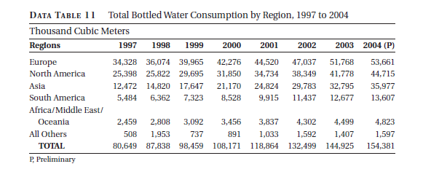

- From the Industry http://www.bottledwater.org/education/environmental-impact/environmental-footprint

- What is the environmental footprint of bottled water?
- What does the bottled water industry do to reduce their waste?
- Are there health risks associated with bottled water?
- How much does bottled water cost?

- The other side of the debate: http://healthresearchfunding.org/bottled-water-pros-cons/. Check out the infographic at the bottom of the page.

- Three reasons for buying bottled water:

- Three disadvantages to buying bottled water:

V. Case Studies in Water
Watch these short videos and note 1. what has happened, 2. what are the effects, and 3. what does the future hold.

- Three Gorges Dam—Reaching Too Far, Not Looking Back
- http://geography.howstuffworks.com/7143-china-three-gorges-dam-video.htm (3:07)
- http://blogs.telegraph.co.uk/news/timcollard/100042402/china-cracks-in-the-three-gorges-dam-so-300000-people-can-wave-goodbye-to-their-homes/ (1:24)

- Aral Sea—It’s a Cotton-pickin’ Shame
- http://www.youtube.com/watch?v=cbSkRS8Ih7o (2:20) https://earthengine.google.org/#intro/AralSea (:20)
- http://www.youtube.com/watch?v=NC5UIEx83fo (10:30)

- Ogallala Aquifer—Our Nation’s Food Future is a Fossil
- http://science360.gov/obj/tkn-video/ea9ba858-6089-4843-86b1-8fcb680e0d5a/sustainability-water-ogallala-aquifer (5:40)
- http://www.youtube.com/watch?v=hZvvsVHp34M (8:51)

- Great Pacific Garbage Patch—A Global Problem That’s Everyone’s Fault
- http://www.youtube.com/watch?v=WtewmJ78hzw (4:50)
- http://www.ted.com/talks/capt_charles_moore_on_the_seas_of_plastic.html (7:20)
- http://www.upworthy.com/people-should-know-about-this-awful-thing-we-do-and-most-of-us-are-simply-unaware?c=ufb1

