DNA Practice Test
(April 18, 2013)

- What do the following prefixes/suffixes mean?

- poly: ______________ b. –ology: _________________

c. uni: _______________ d. homeo: ________________

e. semi: _______________ f. anti: ____________________

g. bio: _______________

- Bears are alive and flowers are alive. What are the 7 characteristics of life that both of these organisms possess that proves they are alive?

- Living things _______________________________________________.

- Living things _______________________________________________.

- Living things _______________________________________________.

- Living things _______________________________________________.

- Living things _______________________________________________.

- Living things _______________________________________________.

- Living things _______________________________________________.

- DNA is a polymer of many smaller units called nucleotides. A protein is a polymer of many smaller units called amino acids. In other words, nucleotides are to DNA

as amino acids are to _____________________.

- What is a peptide bond? ____________________________________________________.

- What does denature mean? ________________________________________________

____________________________________________________________________________.

- What is the difference between a “point mutation” and a “frameshift” mutation?

A point mutation is when ________________________________________________

_________________________________________________________________________.

A frameshift mutation is ________________________________________________

_________________________________________________________________________.

- Why is DNA replication also called “semiconservative replication?”

_______________________________________________________________________________

_______________________________________________________________________________

- Proteins are made for many purposes or functions. List 4 purposes or functions proteins serve in our body.

- ________________________________________.

- ________________________________________.

- ________________________________________.

- ________________________________________.

- What role does a ribosome play in protein synthesis?

_______________________________________________________________________________.

- What is mRNA? _________________________________________________________________

- What function does tRNA serve in protein synthesis?

_______________________________________________________________________________

- List 3 circumstances/environments that can denature a protein?

- _____________________________________________________________________.

- _____________________________________________________________________.

- _____________________________________________________________________.

- List the four bases of RNA, and how they pair.

_____________________ pairs with _______________________

_____________________ pairs with _______________________

- What is the complimentary strand for this strand of DNA?

5’ T C A C A A G G G T C 3’

___ ___ ___ ___ ___ ___ ___ ___ ___ ___ ___ ___ ___

- Where in the cell does transcription take place (in which organelle)? ______________

- Where in the cell does translation take place (in which organelle)? ______________

- Which of the following is the most accurate synonym for “The Central Dogma”?

Protein synthesis, Semi-conservative replication, Catalyst reactio,

________________________________________

18. What does the word, “synthesis” mean? ________________________________________

19. What does a catalyst do in a reaction? __________________________________________

20. What is a codon? ______________________________________________________________

21. On which of the RNA molecules is a codon found? ____________

22. On the 3 lines provided, label the three numbered parts of this nucleotide?

2
1

- _______________________

2. __________________________

3. __________________________
3

23. What is the definition for homeostasis? _________________________________________

________________________________________________________________________________
24. Using the mRNA chart below, and given the following mRNA sequence, list the amino
acid chain that would result if this strand were translated.

5’ A U G G U U C A A U U G U A A 3’

__________, ____________, _____________, ______________

 |  | Codons Found in Messenger RNA
 |  | Second Base
 |  | U |  | C |  | A |  | G
First Base | U | UUU | Phe | UCU | Ser | UAU | Tyr | UGU | Cys | U | Third Base
 |  | UUC |  | UCC |  | UAC |  | UGC |  | C
 |  | UUA | Leu | UCA |  | UAA | Stop | UGA | Stop | A
 |  | UUG |  | UCG |  | UAG |  | UGG | Trp | G
 | C | CUU | Leu | CCU | Pro | CAU | His | CGU | Arg | U
 |  | CUC |  | CCC |  | CAC |  | CGC |  | C
 |  | CUA |  | CCA |  | CAA | Gin | CGA |  | A
 |  | CUG |  | CCG |  | CAG |  | CGG |  | G
 | A | AUU | Ile | ACU | Thr | AAU | Asn | AGU | Ser | U
 |  | AUC |  | ACC |  | AAC |  | AGC |  | C
 |  | AUA |  | ACA |  | AAA | Lys | AGA | Arg | A
 |  | AUG | Met/start | ACG |  | AAG |  | AGG |  | G
 | G | GUU | Val | GCU | Ala | GAU | Asp | GGU | Gly | U
 |  | GUC |  | GCC |  | GAC |  | GGC |  | C
 |  | GUA |  | GCA |  | GAA | Glu | GGA |  | A
 |  | GUG |  | GCG |  | GAG |  | GGG |  | G

25. On the 3 lines provided, label the three numbered parts of this amino acid.
Numbers 2 & 3 refer to the collective molecules (NH₂ and COO) on their respective sides of the amino acid.
2

3

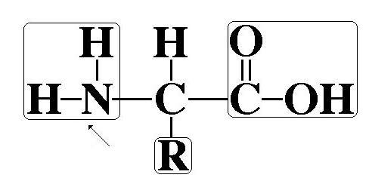
- _________________________

- _________________________

- _________________________

1

Independent Variables vs. Dependent variable Practice: Read the following
experiments and indicate what is the independent variable and what is the dependent variable.

26. A scientist tests her hypothesis that more vitamin C per day will extend a rat’s
life-expectancy. She has 5 groups of rats. Each group receives 2000 more milligrams of vitamin C per day than the previous group. She will then record how long they live.

Independent variable= _____________________________________________________

Dependent variable= _______________________________________________________

27. A scientist wants to study the impact of affection on rat’s energy levels. He has 20
rats. He plays with rat #1 for 1 minute per day. He plays with rat #2 for 2 minutes; rat #3 for 3 minutes and so on to 20 minutes for rat #20. He then records how many minutes the rats spend on their spin-wheels per day.

Independent variable= _____________________________________________________

Dependent variable= _______________________________________________________

28. Mr. Balikian has a hypothesis that time spent studying will cause an increase in test
scores. In one of his biology classes he makes them all stay after school until 5:00 every day during the Genetics unit, and makes them study in complete silence. For his other biology class he tells them to not study outside of class. He will then compare the Genetic Test scores for both classes.

Independent variable= _____________________________________________________

Dependent variable= _______________________________________________________

29. Ms. Michlovich wants to test her hypothesis that heating a cup of water will allow it to dissolve more sugar. She measures how many tablespoons of sugar will dissolve in water at Oº, 20º, 35º, and 55º.

Independent variable= _____________________________________________________

Dependent variable= _______________________________________________________

30. Dr. Balikian noticed that on hot days, the air-conditioned mall seemed to be more crowded. He decided to gather the data. The following is the data he collected:

Outside Temperature (ºF) | Number of People  in the Mall
50 | 450
60 | 450
70 | 600
80 | 700
90 | 800

100 | 1000

Graph this data below. Make sure you include title, units of measurement,
labels for both the “X” and “Y” axis, & constant intervals between numbers. Also, remember that the independent variable goes on the “X” axis.

LAB REVIEW

Strawberry DNA
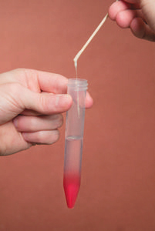
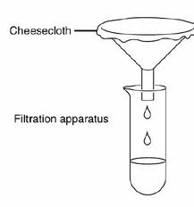
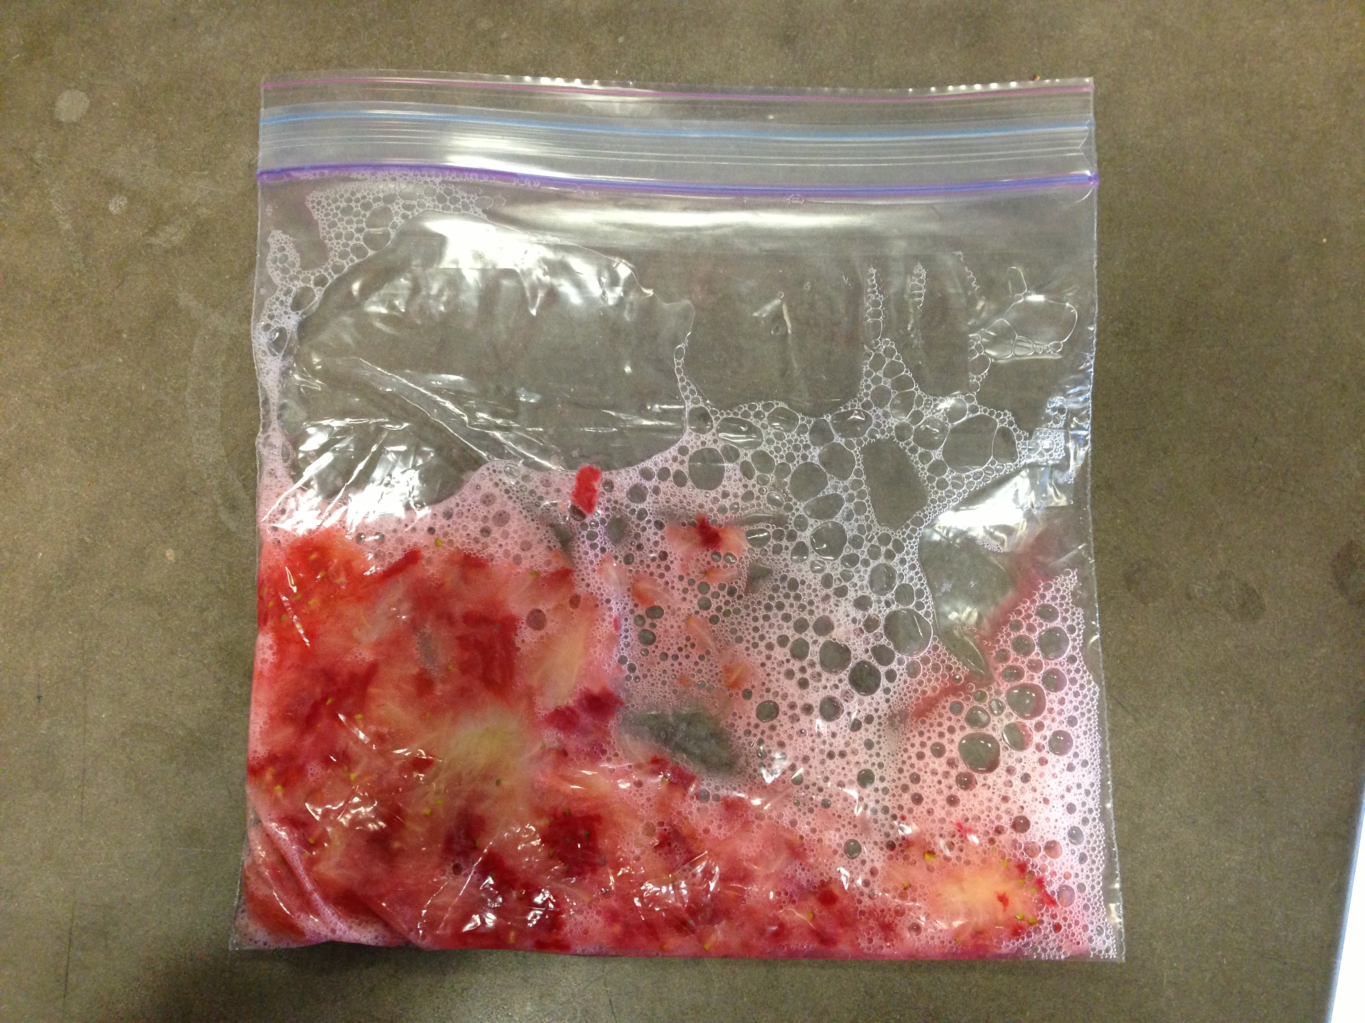

31. What was the purpose of adding meat-tenderizer to the strawberry buffer solution?

_______________________________________________________________________________

32. How would you describe the DNA? What did it look like or remind you of?

_______________________________________________________________________________

Starburst DNA
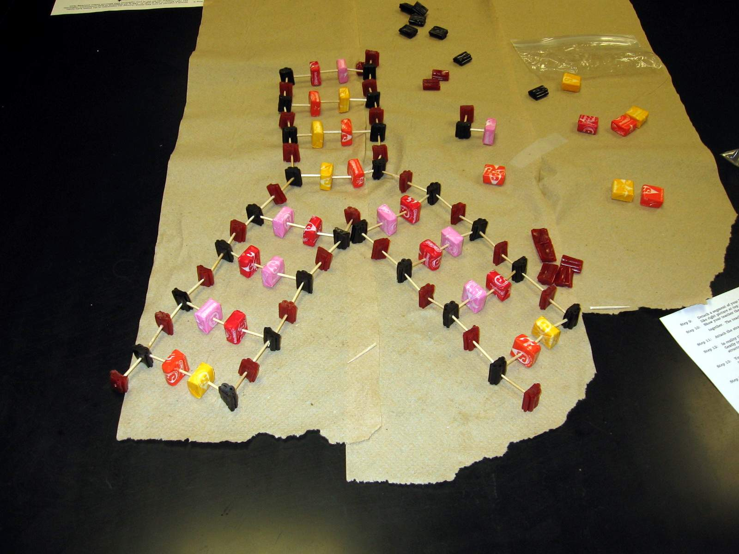
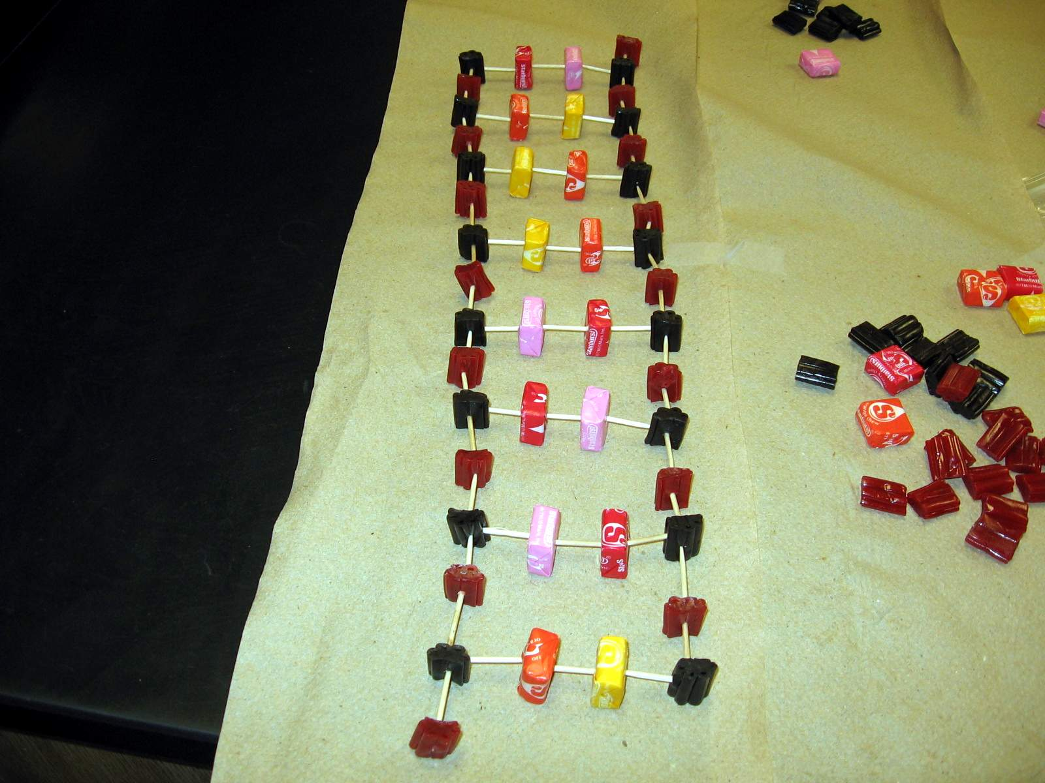
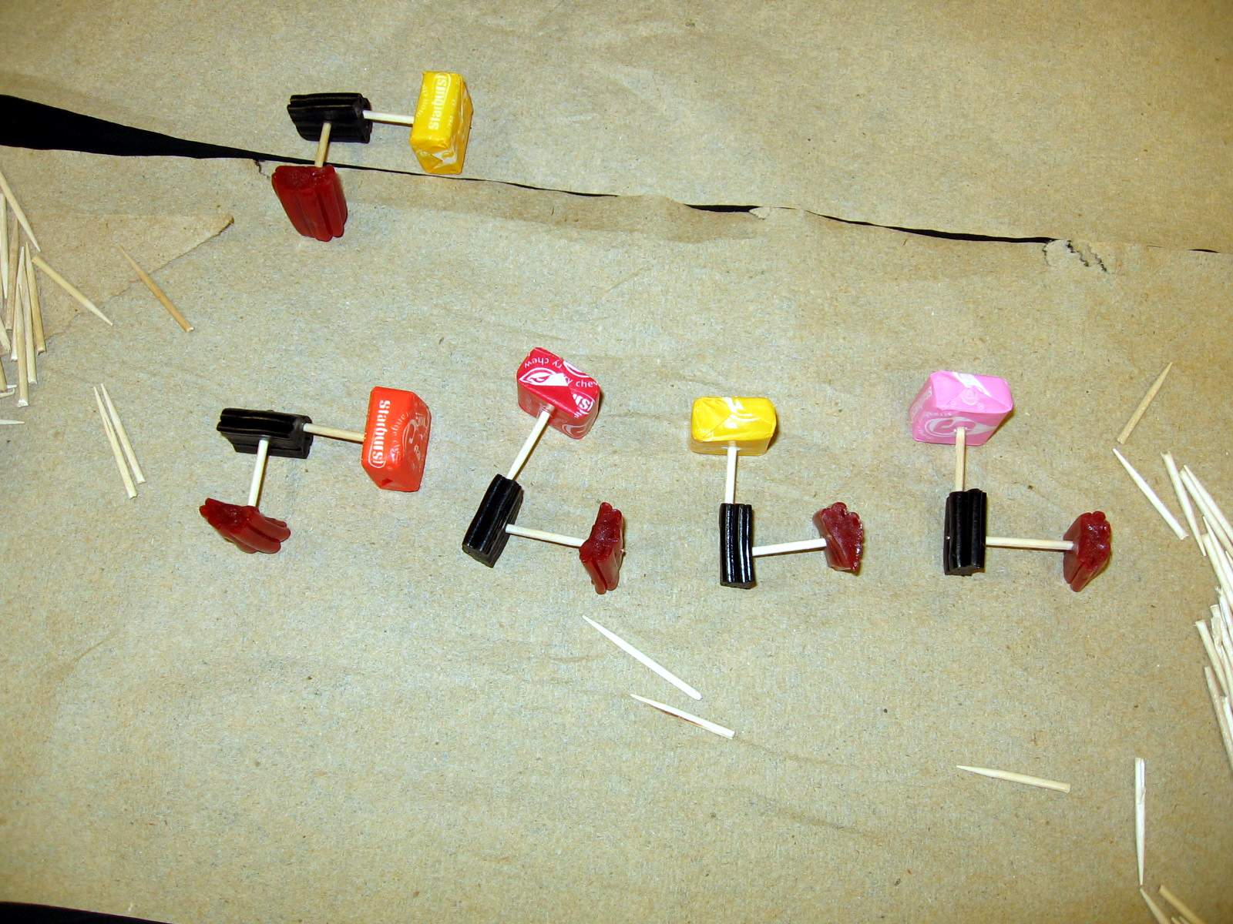

33. You used Candy to model the structure of DNA. What did the Starburst represent?

_______________________________________________________________________________

34. The backbone of the DNA (red and black licorice) represent what two molecules?

____________________________________ _______________________________________

35. What material was used to represent the chemical bonds ?

____________________________________

36. What type of bond holds the “A” and “T” together, as well as the “C” and “G” ?

____________________________________

37. If you inadvertently matched the wrong Starbursts (bases) together, what type of mutation would that be: Frameshift or Point ?

____________________________________

Enzyme lab

38. If you inadvertently matched the wrong Starbursts (bases) together, what type of mutation would that be: Frameshift or Point ?

____________________________________

DNA Practice Test
KEY
September 10, 2103

- What do the following prefixes/suffixes mean?
- poly: Many b. –ology: The study of

c. uni: One d. homeo: Same

e. semi: Half or partial f. anti: Against

g. bio: Life

- Bears are alive and flowers are alive. What are the 7 characteristics of life that both of these organisms possess that proves they are alive?

- Living things are made-up of cells and highly organized.

- Living things are highly homeostatic (strive for homeostasis).

- Living things reproduce.

- Living things grow and develop.

- Living things convert and use energy.

- Living things respond to stimuli.

- Living things adapt to their environment.

- DNA is a polymer of many smaller units called nucleotides. A protein is a polymer of many smaller units called amino acids. In other words, nucleotides are to DNA

as amino acids are to proteins.

- What is a peptide bond? A bond that holds amino acids together in a protein.

- What does denature mean? When a protein unravels, losing its shape and function.

- What is the difference between a “point mutation” and a “frameshift” mutation?

A point mutation is when there is a one base error (wrong nitrogen base)

A frameshift mutation is there a base has been deleted or an extra one added. This “shifts” the codon sequencing, affecting the proper order of amino acids

- Why is DNA replication also called “semiconservative replication?”

Because when the original strand of DNA unwinds and unzips, new nucleotides are added to each parent strand. Thus the parent strand is “conserved” in each of the new DNA molecules that have been replicated.

- Proteins are made for many purposes or functions. List 4 purposes or functions proteins serve in our body.
1. Proteins are enzymes.
- Proteins are hormones.
- Proteins are structural components of the body (hair).
- Proteins are made into antibodies (immune response)
- Proteins are made into muscle filaments
- Proteins are made into hemoglobin (to carry red blood cells)
- Proteins are made into cell membrane receptors and channels.
- What role does a ribosome play in protein synthesis?

It is the site for protein synthesis

- What is mRNA? It is the copy of DNA that is constructed when undergoing protein synthesis.

- What function does tRNA serve in protein synthesis?

Transports amino acids to the ribosome during translation
- List 3 circumstances/environments that can denature a protein?

- Extreme temperatures.

- Extreme pHs.

- Extreme salinity.

- List the four bases of RNA, and how they pair.

Guanine pairs with Cytosine.

Adenine pairs with Uracil.

- What is the complimentary strand for this strand of DNA?

5’ T C A C A A G G G T C 3’
3’ A G T G T T C C C A G 5’

- Where in the cell does transcription take place (in which organelle)? the Nucleus.

- Where in the cell does translation take place (in which organelle)? The ribosome

- Which of the following is the most accurate synonym for “The Central Dogma”?

Protein synthesis, Semi-conservative replication, Catalyst reactio,

Protein synthesis

18. What does the word, “synthesis” mean? putting together

19. What does a catalyst do in a reaction? Speeds up the reaction.

20. What is a codon? 3 consecutive bases on mRNA

21. On which of the RNA molecules is a codon found? mRNA

22. On the 3 lines provided, label the three numbered parts of this nucleotide?
2
1

- Phosphate Group

2. Nitrogen Base

3. Deoxyribose Sugar
3

23. What is the definition for homeostasis? Maintenance of a constant internal environment

24. Using the mRNA chart below, and given the following mRNA sequence, list the amino
acid chain that would result if this strand were translated.

5’ A U G G U U C A A U U G U A A 3’

Met, Val, Gin, Leu

 |  | Codons Found in Messenger RNA
 |  | Second Base
 |  | U |  | C |  | A |  | G
First Base | U | UUU | Phe | UCU | Ser | UAU | Tyr | UGU | Cys | U | Third Base
 |  | UUC |  | UCC |  | UAC |  | UGC |  | C
 |  | UUA | Leu | UCA |  | UAA | Stop | UGA | Stop | A
 |  | UUG |  | UCG |  | UAG |  | UGG | Trp | G
 | C | CUU | Leu | CCU | Pro | CAU | His | CGU | Arg | U
 |  | CUC |  | CCC |  | CAC |  | CGC |  | C
 |  | CUA |  | CCA |  | CAA | Gin | CGA |  | A
 |  | CUG |  | CCG |  | CAG |  | CGG |  | G
 | A | AUU | Ile | ACU | Thr | AAU | Asn | AGU | Ser | U
 |  | AUC |  | ACC |  | AAC |  | AGC |  | C
 |  | AUA |  | ACA |  | AAA | Lys | AGA | Arg | A
 |  | AUG | Met/start | ACG |  | AAG |  | AGG |  | G
 | G | GUU | Val | GCU | Ala | GAU | Asp | GGU | Gly | U
 |  | GUC |  | GCC |  | GAC |  | GGC |  | C
 |  | GUA |  | GCA |  | GAA | Glu | GGA |  | A
 |  | GUG |  | GCG |  | GAG |  | GGG |  | G

25. On the 3 lines provided, label the three numbered parts of this amino acid.
Numbers 2 & 3 refer to the collective molecules (NH₂ and COO) on their respective sides of the amino acid.
2

3

- The “R” group.

- The amine group.

- The carboxyl group.

1

Independent Variables vs. Dependent variable Practice: Read the following
experiments and indicate what is the independent variable and what is the dependent variable.

26. A scientist tests her hypothesis that more vitamin C per day will extend a rat’s
life-expectancy. She has 5 groups of rats. Each group receives 2000 more milligrams of vitamin C per day than the previous group. She will then record how long they live.

Independent variable= Amount of Vitamin C

Dependent variable= Life-Expentancy (how long they live)

27. A scientist wants to study the impact of affection on rat’s energy levels. He has 20
rats. He plays with rat #1 for 1 minute per day. He plays with rat #2 for 2 minutes; rat #3 for 3 minutes and so on to 20 minutes for rat #20. He then records how many minutes the rats spend on their spin-wheels per day.

Independent variable= Minutes Rats Are Played With

Dependent variable= Minutes that the rats Spend on their spin-wheel

28. Mr. Balikian has a hypothesis that time spent studying will cause an increase in test
scores. In one of his biology classes he makes them all stay after school until 5:00 every day during the Genetics unit, and makes them study in complete silence. For his other biology class he tells them to not study outside of class. He will then compare the Genetic Test scores for both classes.

Independent variable= Time Spent Studying

Dependent variable= Scores on the Genetics Test

29. Ms. Michlovich wants to test her hypothesis that heating a cup of water will allow it to dissolve more sugar. She measures how many tablespoons of sugar will dissolve in water at Oº, 20º, 35º, and 55º.

Independent variable= Temperature of the Water

Dependent variable= Amount of Tablespoons of Sugar Dissolved

30. Dr. Balikian noticed that on hot days, the air-conditioned mall seemed to be more crowded. He decided to gather the data. The following is the data he collected:

Outside Temperature (ºF) | Number of People  in the Mall
50 | 450
60 | 450
70 | 600
80 | 700
90 | 800

100 | 1000

Graph this data below. Make sure you include title, units of measurement,
labels for both the “X” and “Y” axis, & constant intervals between numbers. Also, remember that the independent variable goes on the “X” axis.

