Name: ______________________________________
Energy Sources Websites
Part 2: Renewable Resources
Website #1: Energy Kids www.eia.gov/kids/ Click on Energy Sources and Renewable
- In 2014, ______% of total US energy consumption came from renewable sources
- _______ % of US electricity was generated from renewable sources

Why don't we use more renewable energy?
1.

2.

Click on Biomass from the sidebar
Biomass: _____________________________________________________________________
Examples:

How is the energy from biomass released?
1.
2.

What is waste-to-energy?

- Americans throw away ________ pounds of trash a day.
- ________% is recycled, ________% is converted to energy, and ________% is discarded into landfills
What is biogas? How is it produced? | 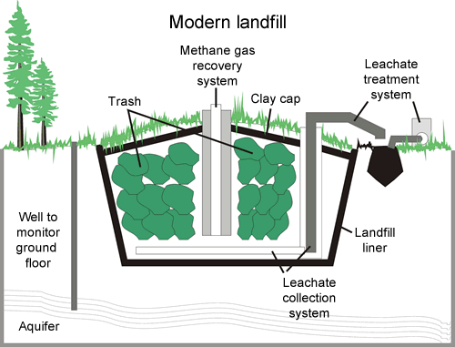
Advantages of Biomass:

Disadvantages of Biomass:

Why is growing plants (like corn) for biofuel (like ethanol) controversial?

Click on Geothermal
Geothermal energy is generated in the earth’s ______________ .
Three ways geothermal energy finds its way to the earth’s surface:  1.  2.  3. | 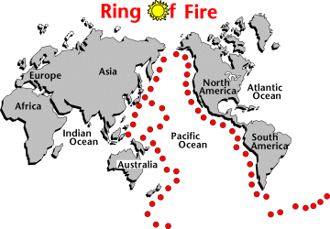
Most geothermal resources are found near ________________________________________________ .
In the US, most of the geothermal resources are found in _____________________________________.
Three types of geothermal energy systems:
1.
2.
3.

Which country produces the most electricity from geothermal resources? __________________
Which state? ________________________________
Summarize how these resources are converted to electricity. Use the paragraph under “Geothermal Power Plants”. You do not need to know the three types of geothermal power plants.

Advantages of Geothermal:

Disadvantages of Geothermal:

Click on Hydropower
Hydropower: __________________________________________________________________________
Where do hydroelectric power plants need to located? (duh) ___________________________________
Two types of flowing water that contain mechanical energy:  1.  example:  2.  example: | How was hydropower used thousands of years ago?
Most hydropower in the US is used in these states: | Circle True/False: All dams in the U.S. produce electricity.  Most dams were constructed for __________________________________________ .

Advantages of Hydropower:

Disadvantages of Hydropower:

How do we reduce impacts of dams on anadromous fish populations, like salmon? (Anadromous: spend part of their life cycle in freshwater rivers, part of it in the ocean)

Tidal energy is more _______________________________ than wind or solar energy.
- Economically, a tidal range of _____________________ is needed to produce tidal energy.
- How many tidal power plants are there in the US? ____________
Wave energy has good potential but not much development yet. Places that are good possibilities for waver power plants include ___________________________________________________________.
Click on Solar
Two ways solar energy is converted into electricity:
1.
2.
Two main benefits of solar energy:  1.  2. | Two main limitations of solar energy:  1.  2.
Where will you find the most usage of solar energy in the US? __________________________________
How much of the world’s deserts would need to be covered with photovoltaics to supply all the world’s electricity? ______%
How Photovoltaic Cells work  - PV cells are made of _____________________________ material  - __________________ photons provide energy to generate electricity  - When enough sunlight is absorbed, _____________ are released from the material’s atoms  - The electrons flow towards the front of the cell and create an imbalance of __________________________, or a _______________ potential, like the +/- of a battery  - Electrical _______________________ absorb the electrons, and are connected in an electrical _________. | 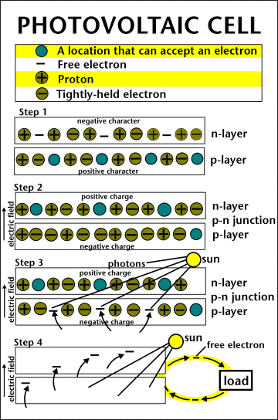
Efficiency right now of PV cells ranges from ___________________
Advantages of PV systems:
1.
2.
3.

What is solar thermal power? How is it different from using PV cells?

- Solar heating systems may be passive or _____________________.
- Active systems use a _____________________ and a fluid to collect and absorb solar radiation.
- Collectors may categorized as ________________________ or ______________________ .
Advantages of Solar Energy:

Disadvantages of Solar Energy:

Click on Wind
Wind energy is _______________________________________________________________ .
- Wind ______________________ use blades to collect wind’s kinetic energy
- Turbines are connected to a drive shaft that turns an electric ___________________________ .
Electricity generation from wind has increased from
_________________ kWh (2000) _________________ kWh (2014)

Why has this dramatic increase occurred?
1.
2.

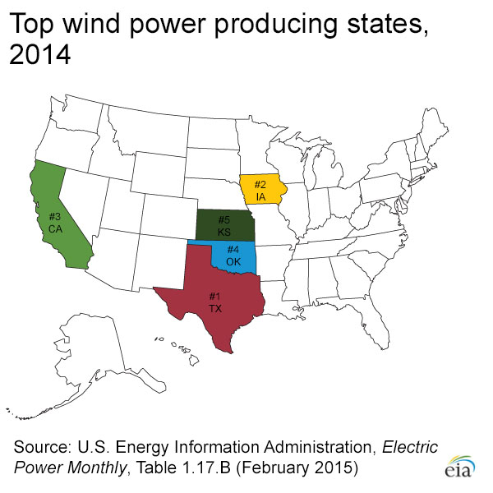  Good sites for wind turbines: | 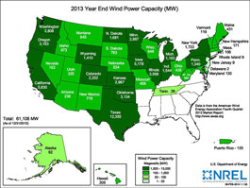  Two types of wind turbines:  1.  2.
 | What are turbines grouped together as wind power plants called? _______________________
Explain the causes of the expansion of wind energy use, starting in the 1970s.

Advantages of Wind Energy:

Disadvantages of Wind Energy:

Site 2: http://www.wonderville.ca/asset/save-the-world Save the World Game. Watch the intro animation and then click Continue. Watch the animation for electricity generation.
Electricity Generation
- Water, steam or air turns the ______________________ and connects to a ____________________
- Inside the generator is a ______________ and a ____________________
- The ____________________ turns the ____________________
- The magnet turns over the coil, generating electricity in the copper wire, through the process of ____________________________________________________________
- Energy might be distributed through ________________________________________ or stored in a ____________________________

Click continue and play the game. Which form of power is discussed at the completion of each of the regions? | Norway
 | Canada
 | U.S.
 | France
 | India
 | Japan
 | New Zealand
Site 3: http://climatekids.nasa.gov/power-up/ Climate Kids game. Use the left/right arrows to keep the solar panel in the sun, and the up/down arrows to keep the windmill in the wind. Try to power up all the houses in 2 minutes. What award did you win at the end? ___________________________________

Site 4: http://www.alliantenergykids.com/FunandGames/OnlineGames/KIDS_GAME_FLOW_OF_ENERGY Alliant Energy Kids—Flow of Energy

Track the flow of energy for Watching Television.
1. | 2. | 3. | 4. | 5.

10. | 9. | 8. | 7. | 6.

11. | 12. | 13. | 14. | 15.

Track the flow of energy for Taking a Hot Shower.
1. | 2. | 3. | 4. | 5.

10. | 9. | 8. | 7. | 6.

